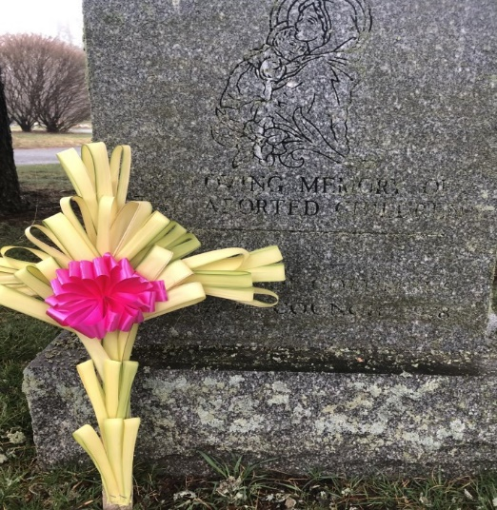
EASTER PALM CROSSES

The palms are blessed and are accompanied with a

prayer to be said when placing the cross at your loved one’s grave

COST: $15.00 EACH ORDER BY: Monday, April 6th
PICK UP: Saturday April 12th &
Sunday, April 13th after all Masses

Pickup at St Bridget School Library
Send the completed form and payment to:
“St. Bridget of Sweden Women’s Society”
175 Main St., Cheshire, CT 06410
or drop an envelope marked “Palm Cross Sales” in the collection basket at Mass

Information: Cheryl Foti, (203)988-7166 or pcfoti@cox.net

CHECKS PAYABLE TO: ST. BRIDGET OF SWEDEN WOMEN’S SOCIETY NAME: PHONE: EMAIL: QTY:
If you wish us to place a cross at a grave in St Bridget of Sweden Cemetery, please write their names below and the location of the gravesite.
DECEASED NAME(S) __________________________________________________
____________________________________________________________________
GRAVESITE__________________________________________________________
____________________________________________________________________

